Financial Analysis and Profitability Report

Data Cleaning & Transformation
- The dataset was cleaned by removing blank values, correcting data types, and handling negative and inconsistent values.
- Data transformation was done using Power Query to make the data suitable for analysis and reporting.

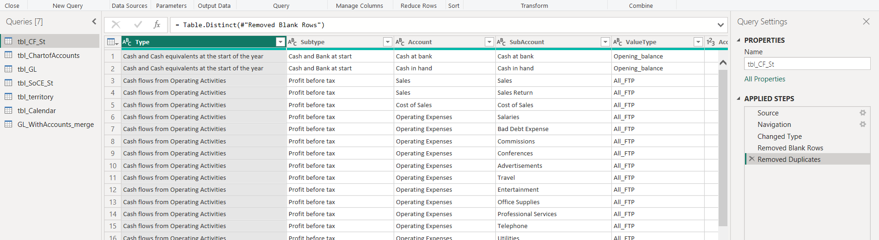
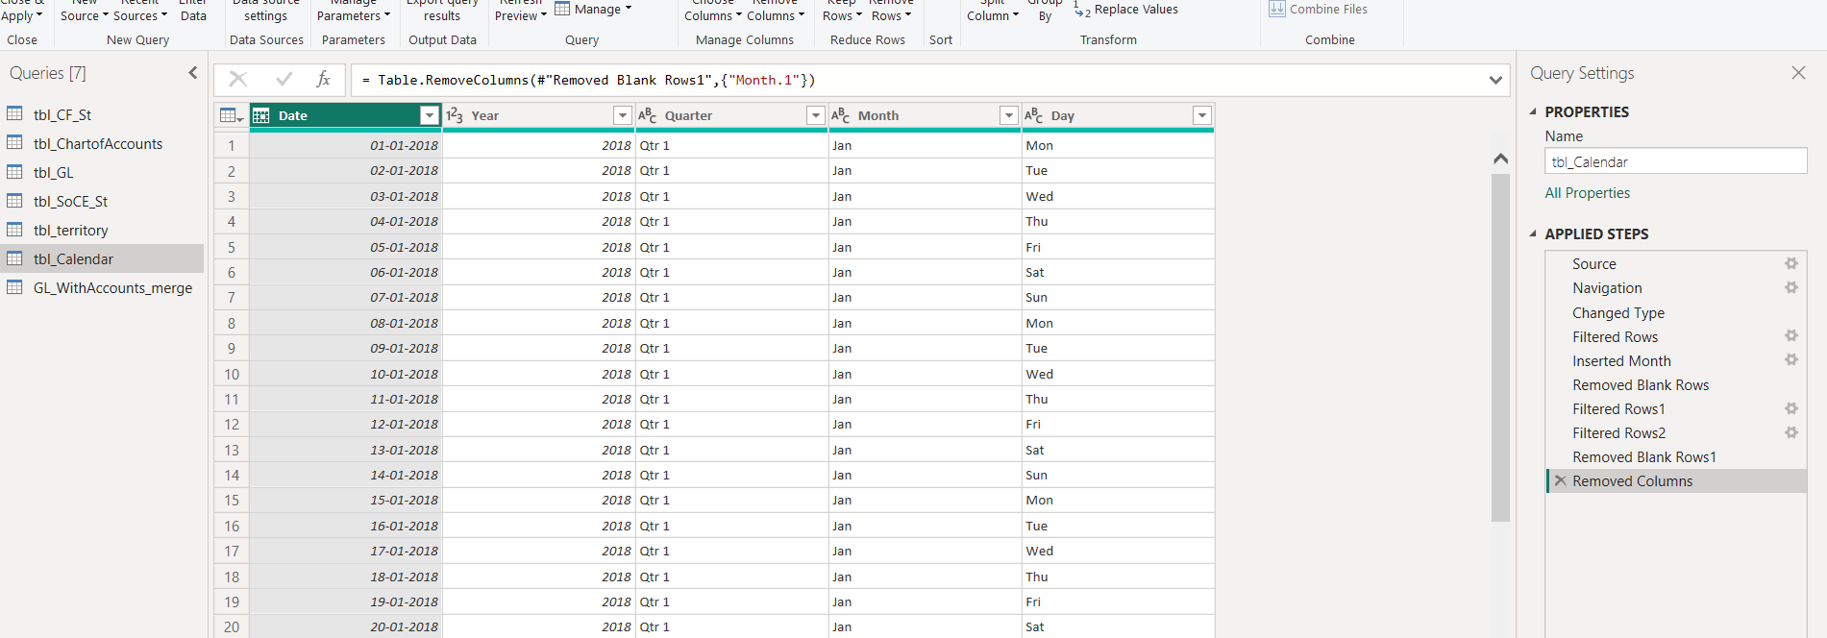
DAX Functions
- DAX functions were used to calculate key business metrics.
- Functions like CALCULATE, SUM, and FILTER were applied to derive Revenue, Expenses, Total Inflow, Total Outflow, and Net Cash Flow.
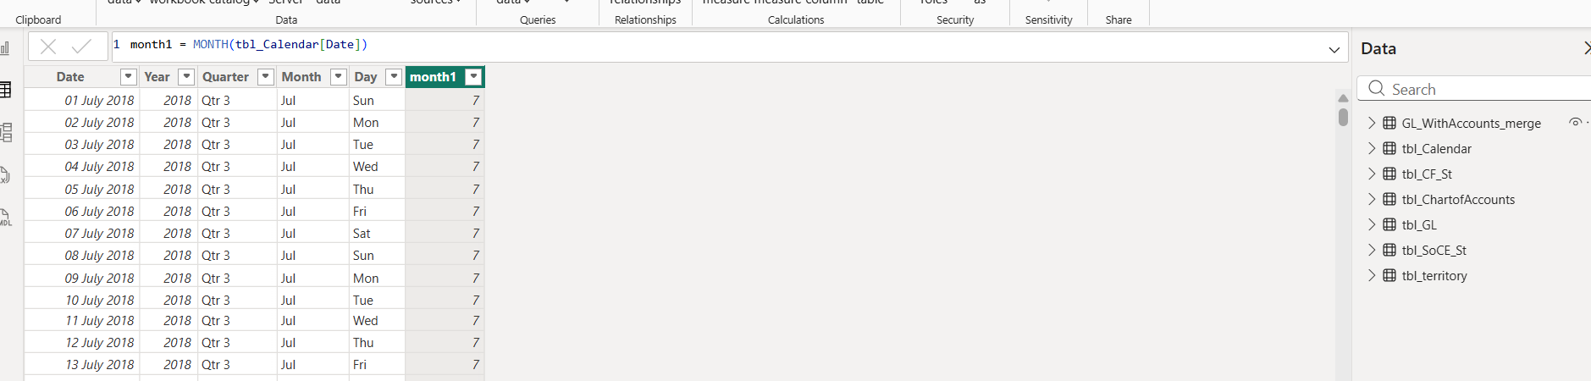
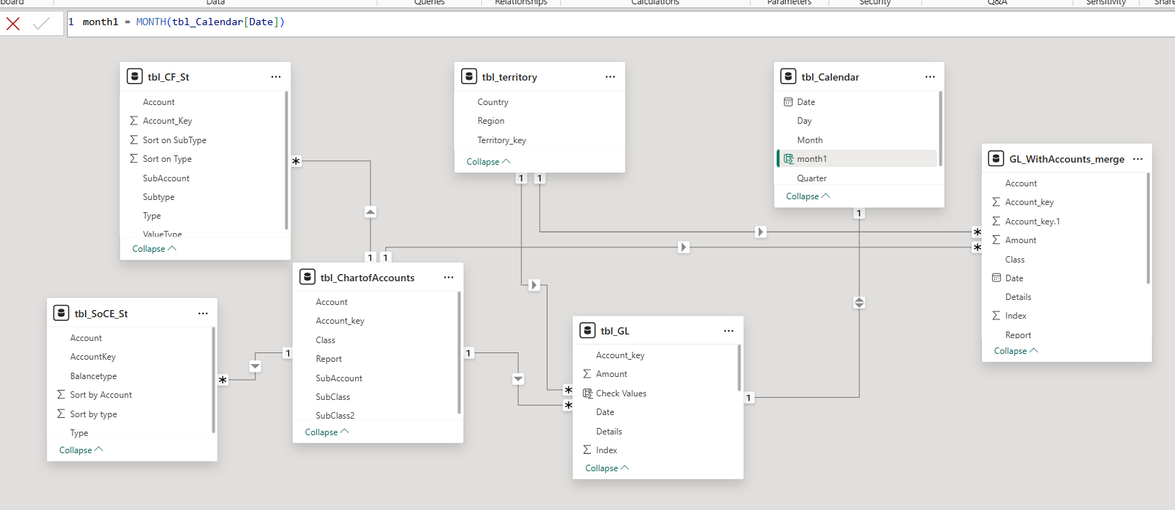

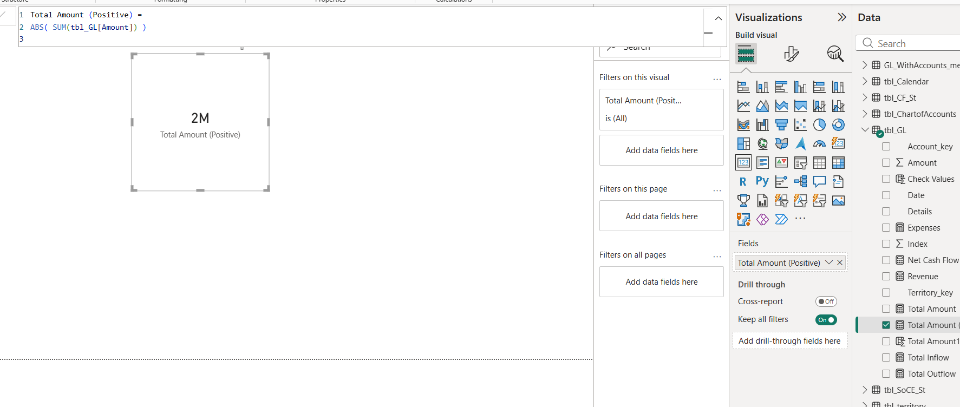
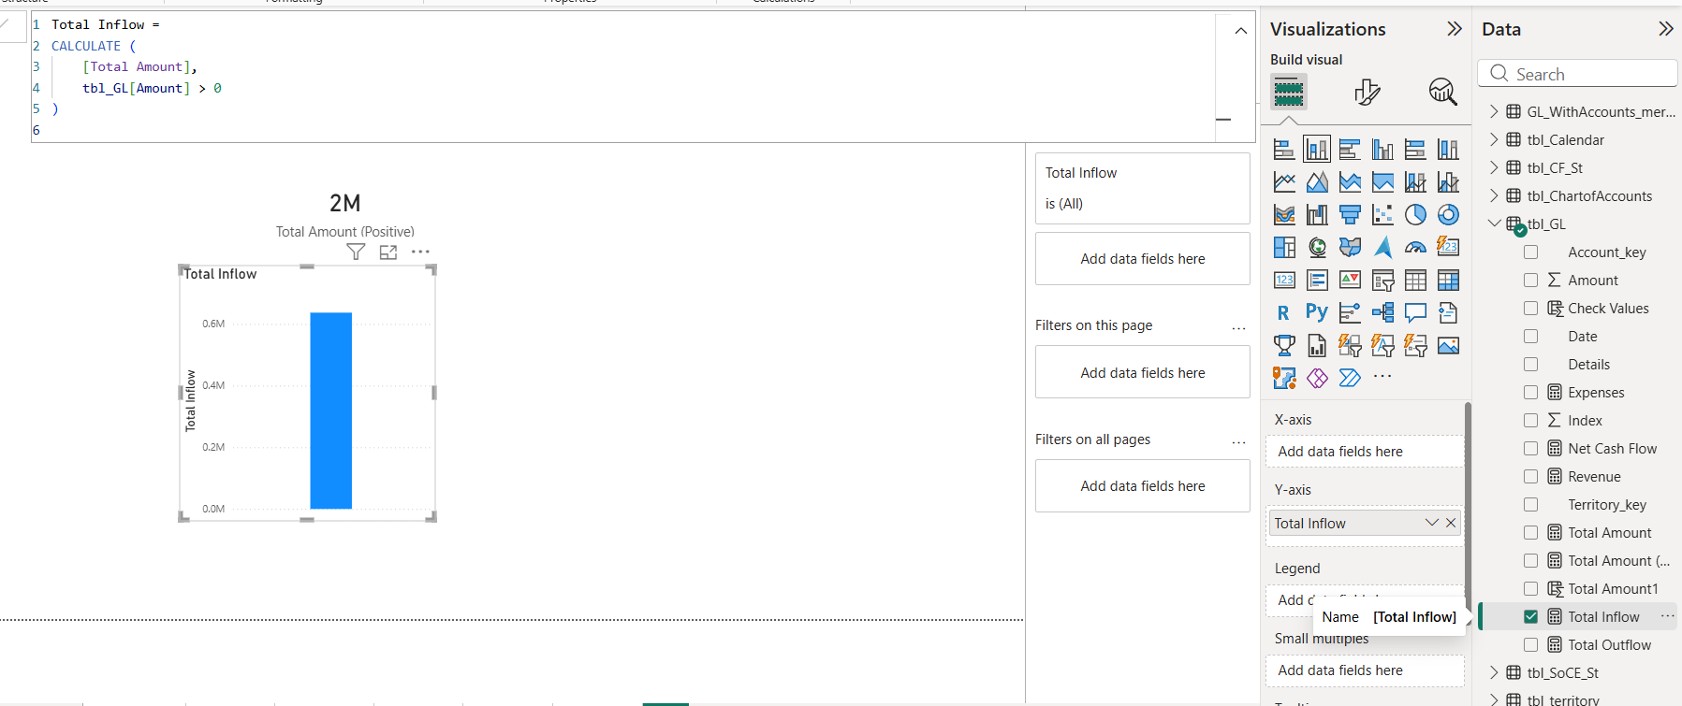

Dashboard Design
- The dashboard was designed to be simple and user-friendly.
- It includes KPI cards, bar charts, line charts, pie charts, and waterfall charts to clearly visualize financial performance.

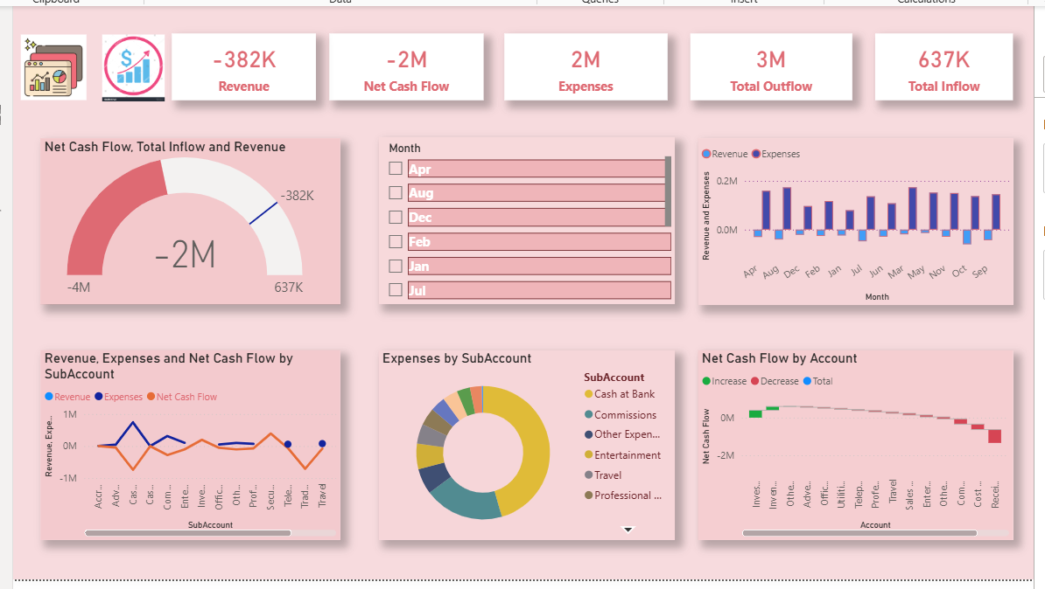

Insights & Analysis
- The dashboard provides insights into monthly revenue and expenses trends.It helps identify periods of high expenses, low revenue, and negative cash flow, supporting better financial decision-making.

Report
- This report presents a comprehensive analysis of the organization’s financial performance using Power BI.
- It consolidates data on revenue, expenses, inflow, outflow, and net cash flow into an interactive dashboard.

- The report enables users to analyze financial trends across months, years, and accounts through slicers and dynamic visuals.KPI cards highlight key metrics, while charts provide deeper insights into financial behavior and performance variations.

- Overall, this report supports data-driven decision-making by offering clear, accurate, and visually engaging financial insights.

